Week 35 Practical Session 2021 – 2022 Computer Crime and Digital Evidence

Prefetch files

Issued by Jay Murphy

Date Issued: 15th March 2022



Submitted by: Sneha Yadav
Sec-A CSDF L4
UWE ID: 24071275

    - Which browser was used last on this computer and when?
- Yes, CHROME browser was last used on this computer on 2013/12/27 on 07:41:45 UTC.
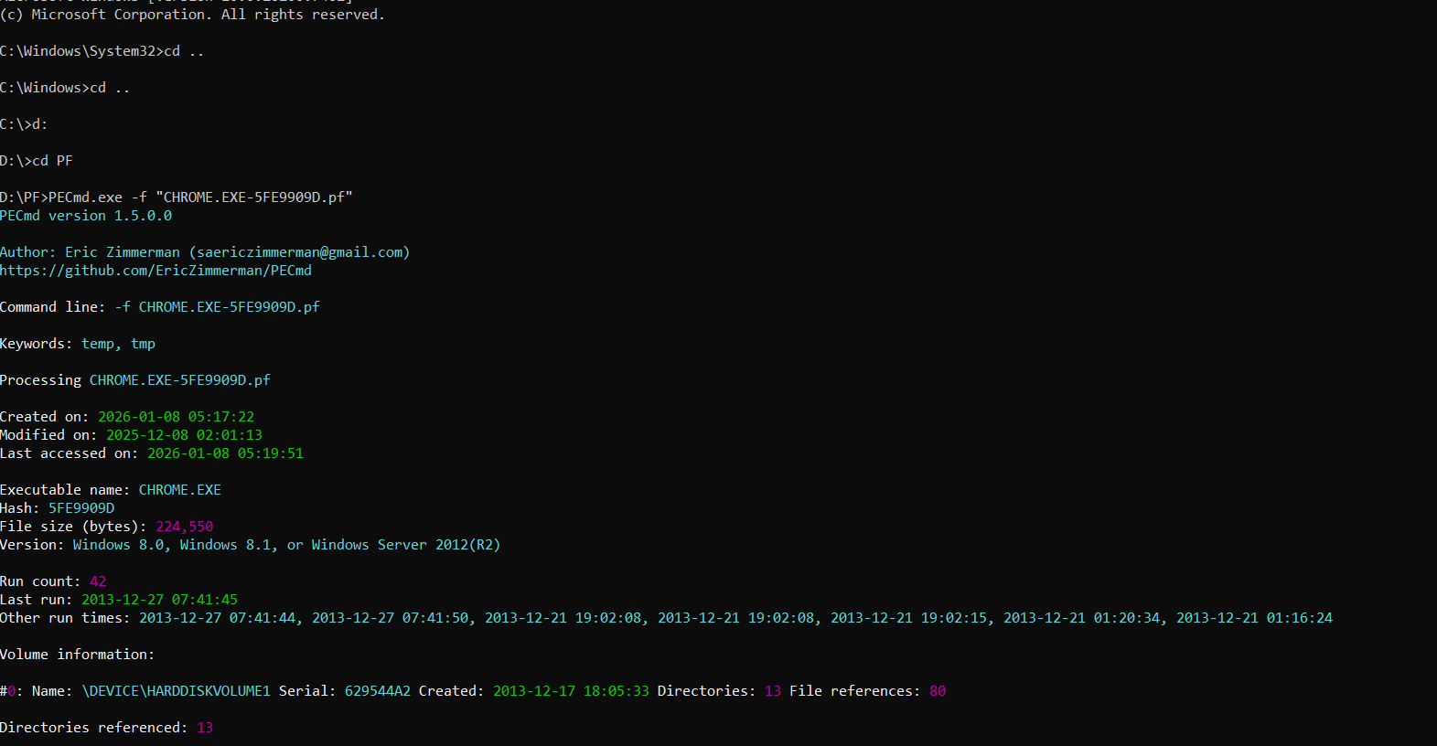

    - Did the user ever launch the Snipping Tool? If yes when?
- Yes, the user did launch the Snipping tool on 2013/12/21 at 1:00:33 UTC
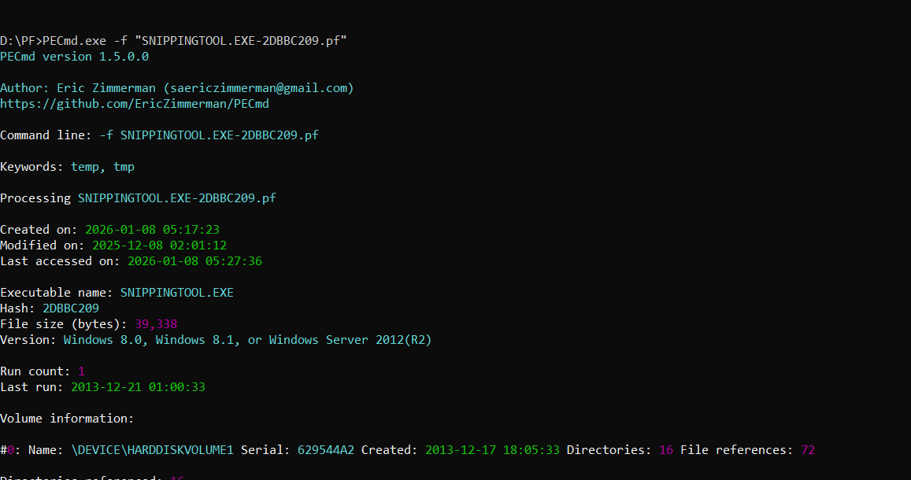

    - Was GIMP launched the day it was installed? What day was it?
- No, GIMP was not launched the day it was installed. It was first launched on 2013/12/20 at 21:38:38 UTC.
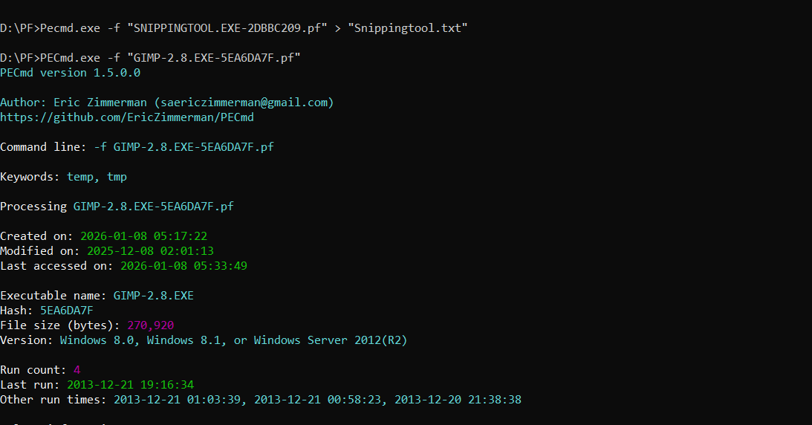

    - How many times Google Chrome was run on this PC?
- Google Chrome was run 42 times on this PC.


